**Main page – On running the application on server –**

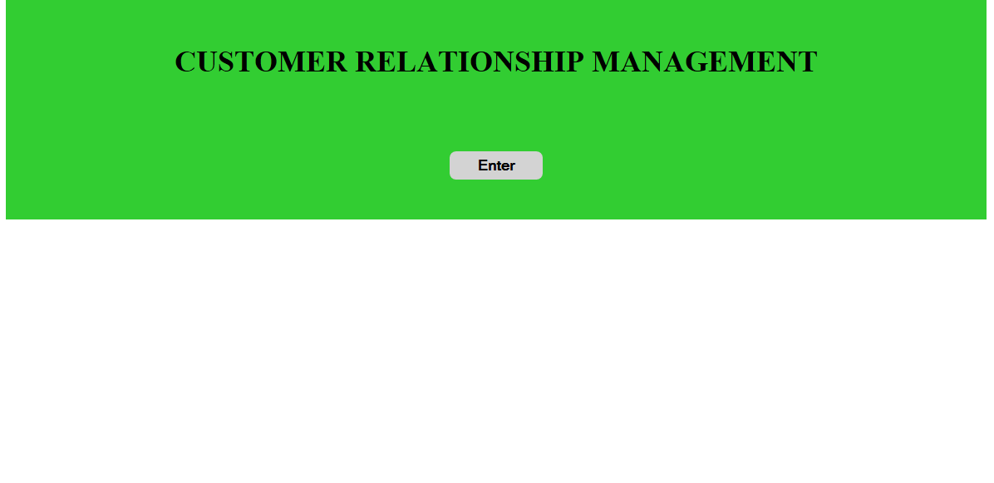

**Hit ENTER – Empty table**

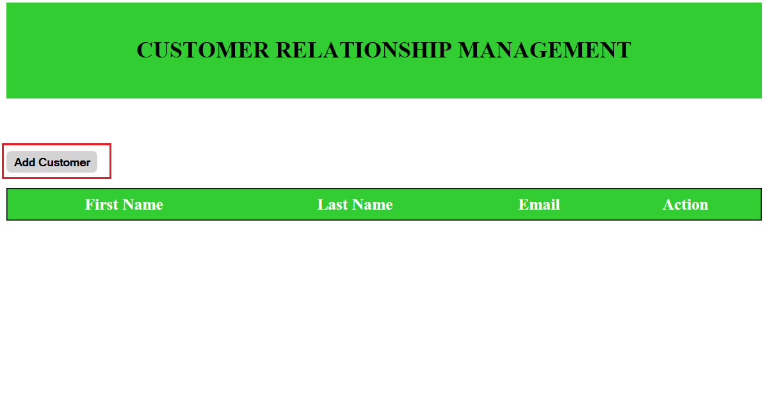

**Add Customer –**

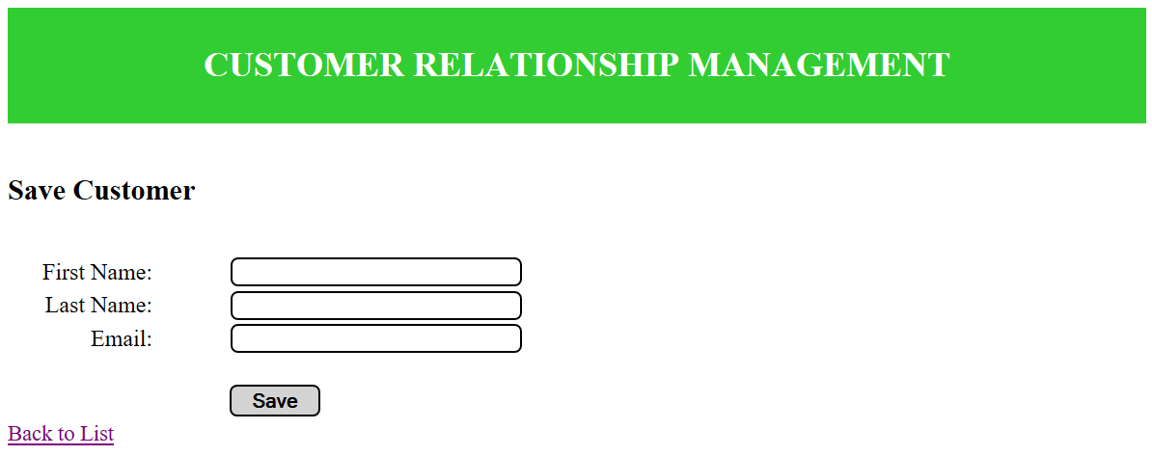

**Add Customer details –**

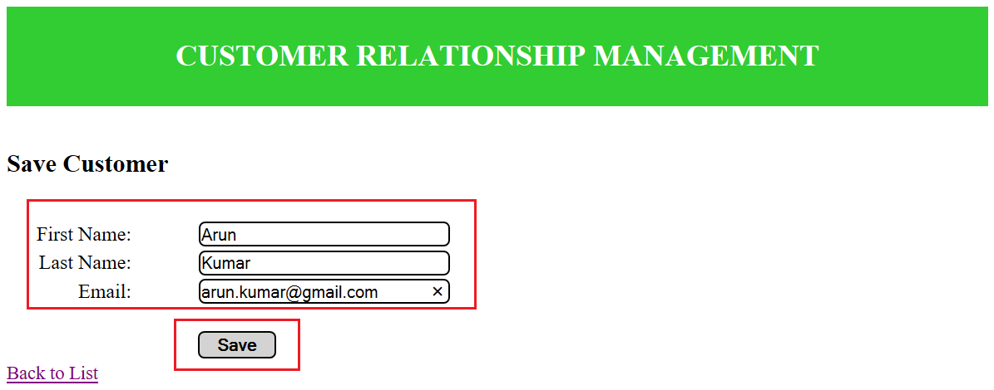

**On Clicking – SAVE**

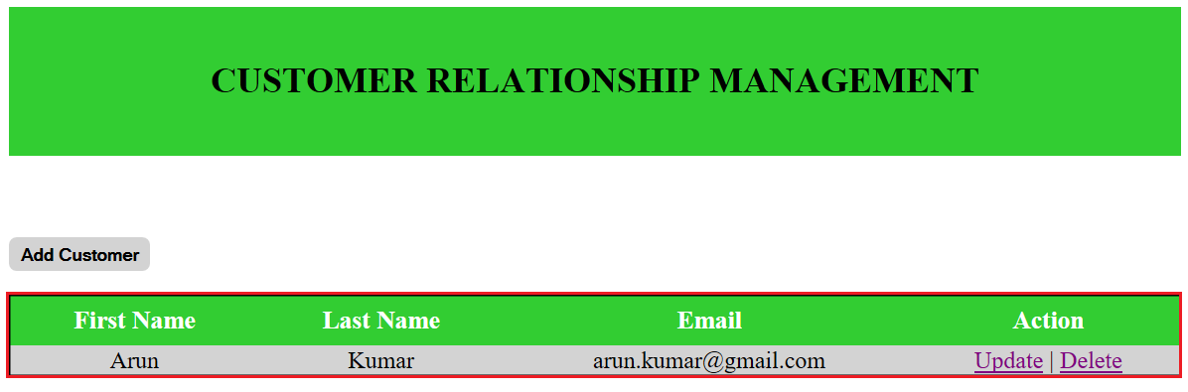

**After adding more Customers –**

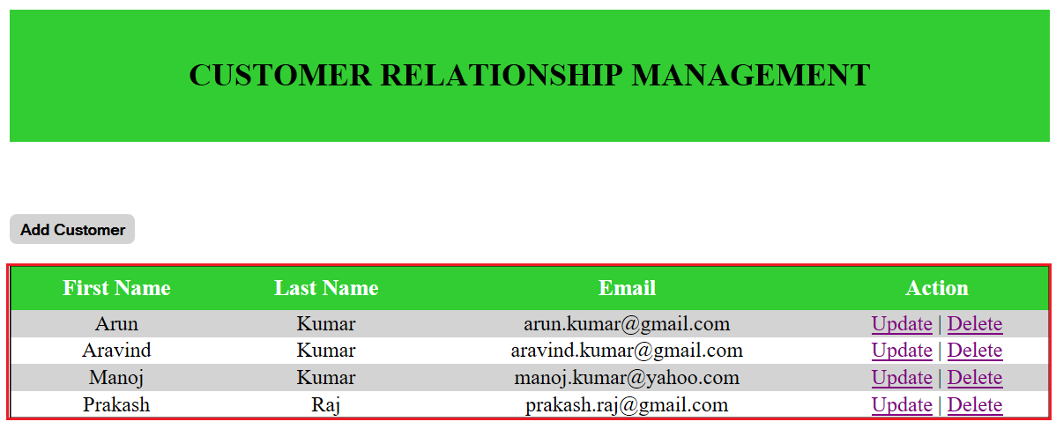

**Table in MySql –**

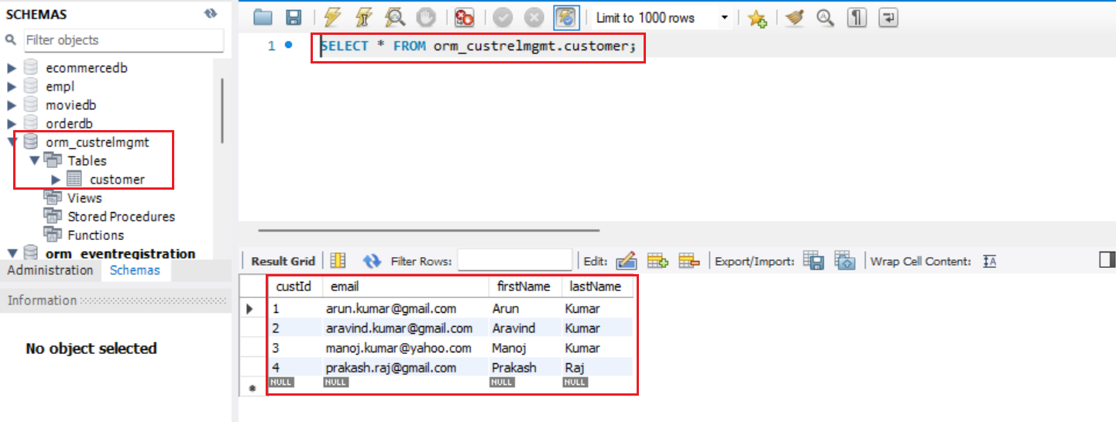

**Update –**

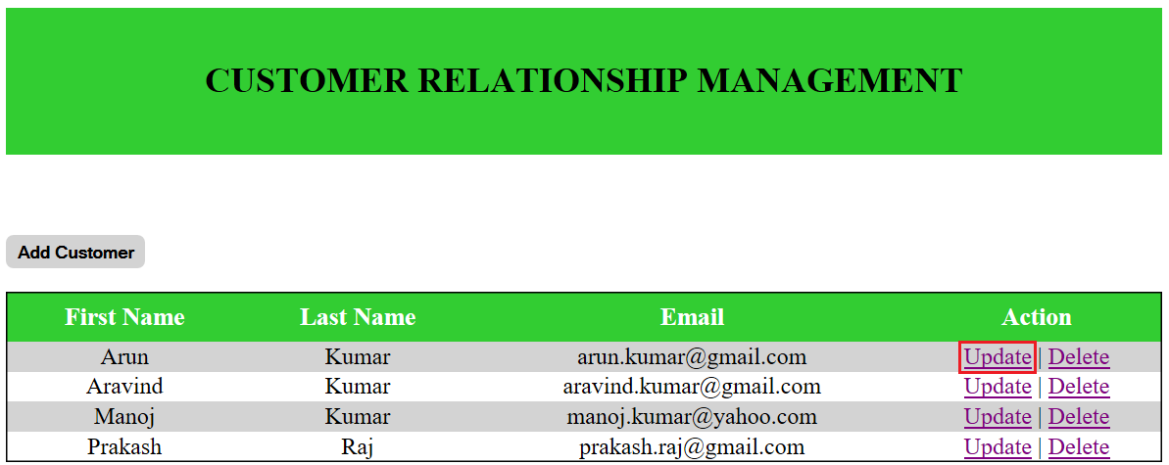

**On Clicking Update option –**

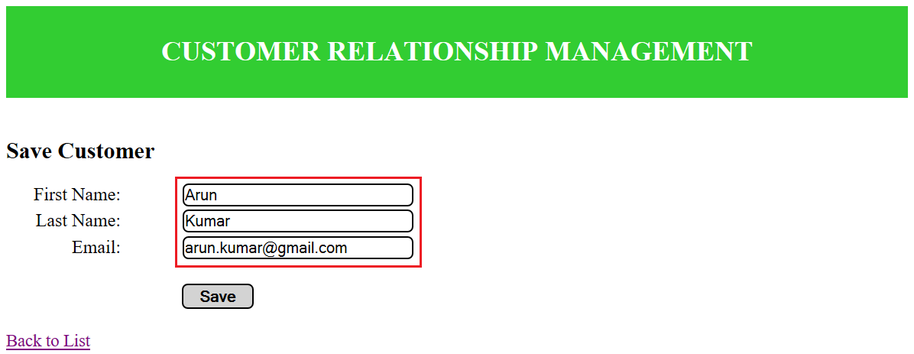

**Changing First Name - “Arun” to “Sriram” and Email –** [**arun.kumar@gmail.com**](mailto:arun.kumar@gmail.com) **to** [**Sriram.kumar@gmail.com**](mailto:Sriram.kumar@gmail.com)

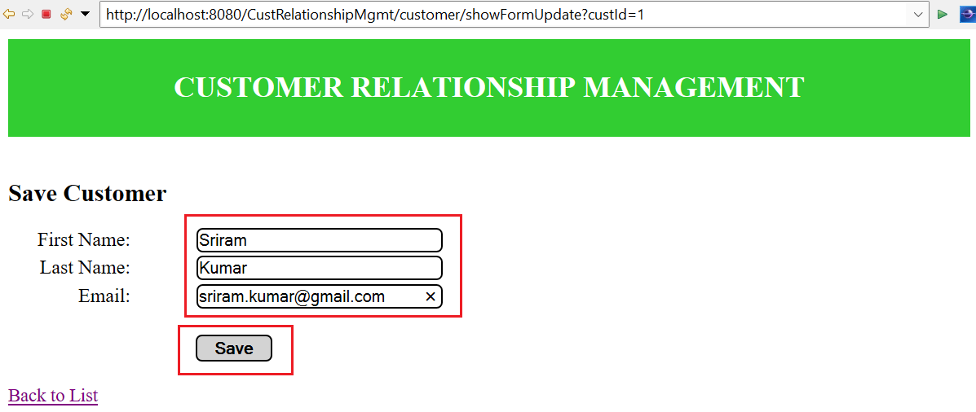

**On Clicking SAVE –**

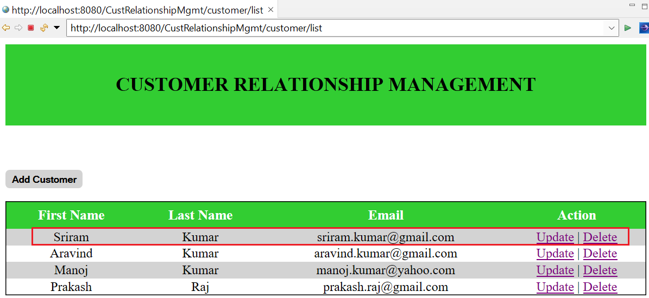

**Delete –**

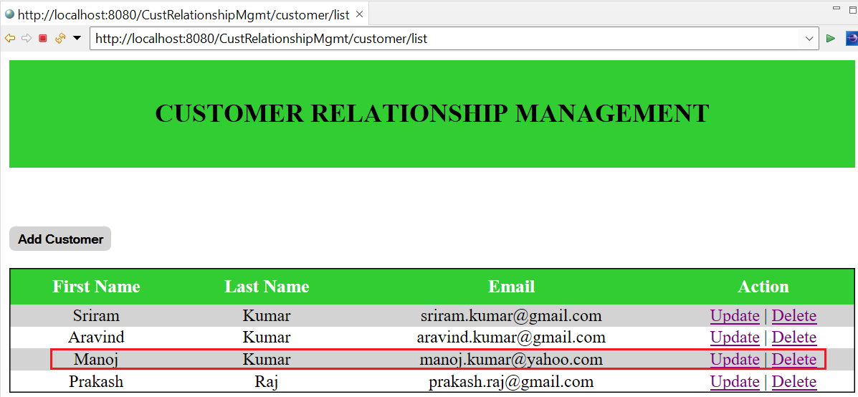

**On Clicking Delete option**

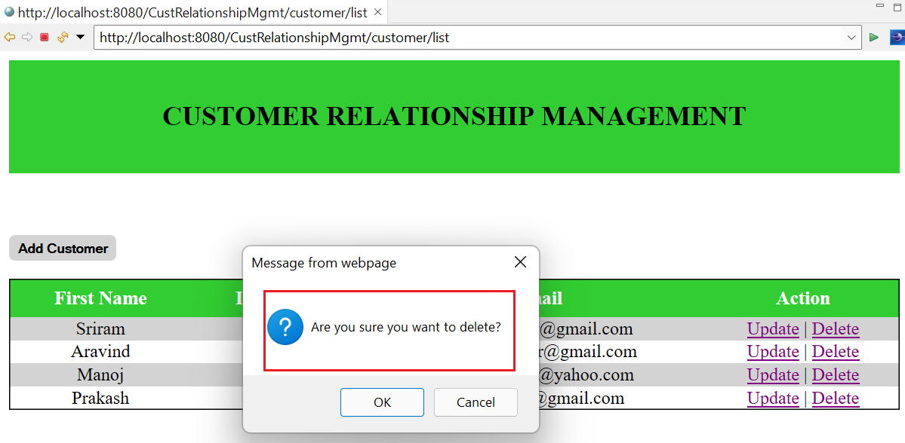

**On Clicking OK –**

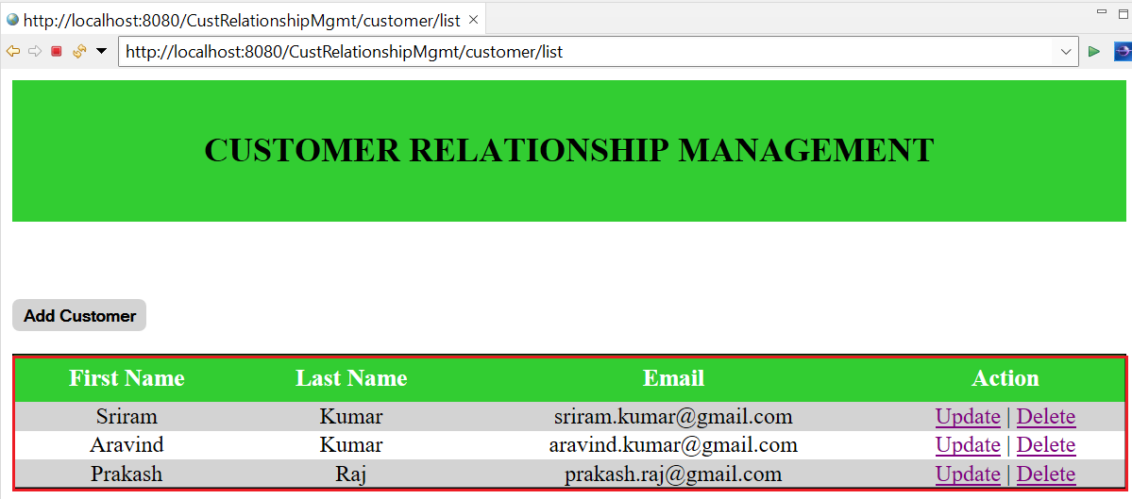

**Trying to add the same row again –**

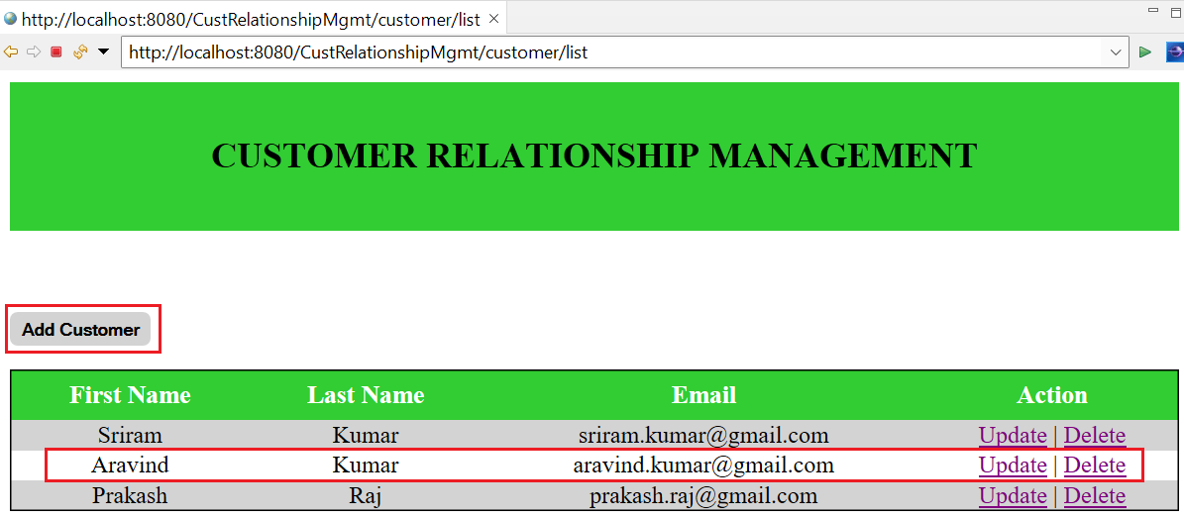

**Clicking “Add Customer”**

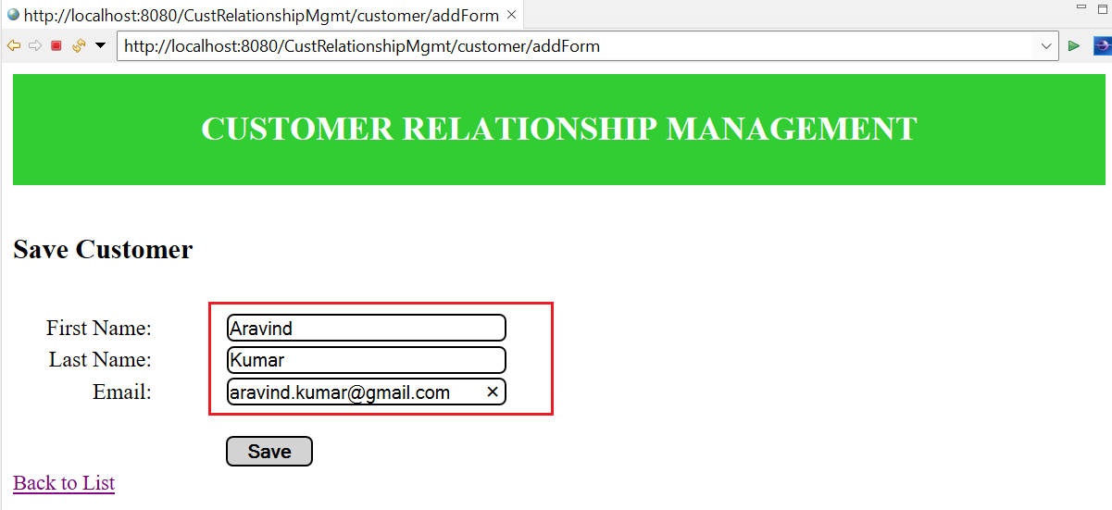

**On Clicking SAVE –**

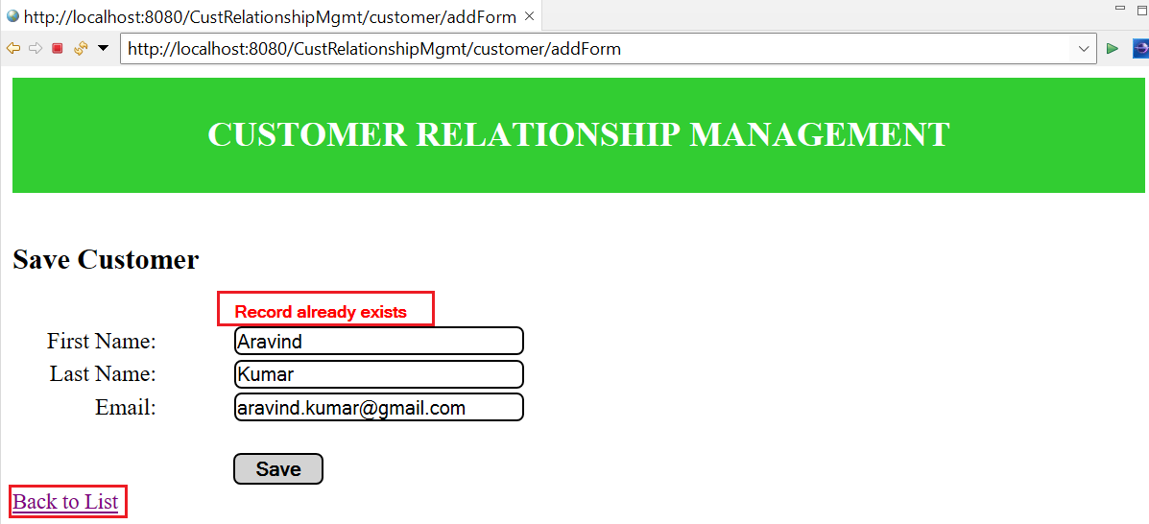

**On Clicking “Back to List” –**

